UT 27
DRESSING AND PROCEDURE TROLLEY
 | Construction: | Electrostatic powder painted metal frame and ABS
 | Body Material: | Side walls and drawers electrostatic powered painted steel sheet  Working top and removable drawers trays ABS material
 | Knocking Mechanism: | Central locking system with key
 | Top Surface: | ABS work top with raised edges on three sides to prevent falling
 | Drawers: | 1 medium with 120 mm height + 1 big 220 mm height  Optional: 3 mediums with 120 mm height  Built in drawer handles with different colours
 | Drawer Dimensions: | 1 pcs medium drawer: 355 x 555 x 100 mm  1 pcs big drawer: 355 x 555 x 200 m  Inner dimensions
 | Inside Drawers: | Made by ABS material, easy detachable trays  Each drawer totally 2 separators for 4 compartments
 | Pull-put Working Tray: | High quality and rigid stainless steel working tray for medical staff  304 grade steel tray with railing system  295 x 350 mm dimension
 | Medicine Boxes: | 10 pcs of, tilt-out, and transparent medicine boxes
 | Castors: | 2 pcs lockable, 2 pcs without lock, 125 mm  360° swivel castors, made of non-marking material
 | Waste Bin: | Detachable bin, made by PE material
 | IV Hook: | Stainless steel, 4 hooks, IV pole, height adjustable
 | Label Holder: | Label holder on each drawer for easy identification

 | TECHNICAL DETAILS
 | Body Dimensions | : 700×550 mm
 | Height | : 1150 mm
 | Castor Diameter | : 125 mm

OPTIONAL ACCESSORIES
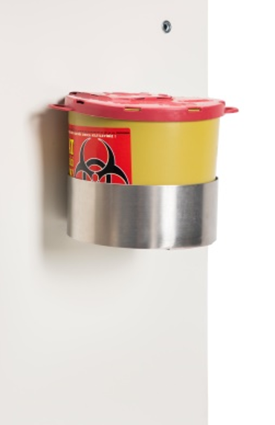
Sharp Box
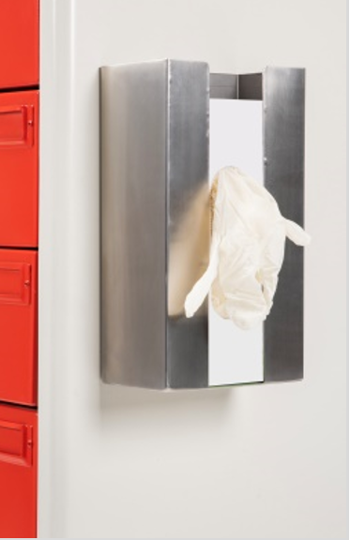
Glove Box Holder
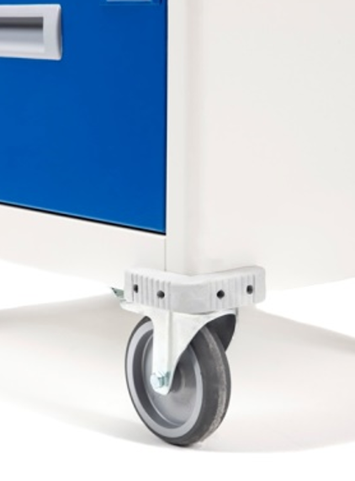
Plastic Bumpers
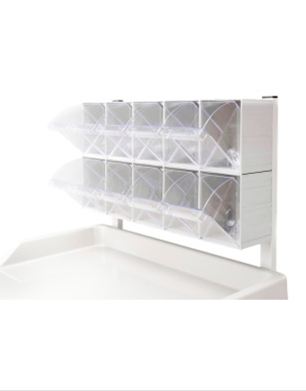
10 pcs. Medicine Box

